Grp #60

BDS ASSIGNMENT 1

MANISH KUMAR

MEGHARAJ S HOLIYAPPA

Table of Contents

a) The Schema / Structure 2

○ MongoDB 2

○ PostgreSQL 7

○ Cassandra 15

b) Queries used for each of the below operation 24

○ MongoDB 24

● WRITE 24

● READ 25

● DELETE 25

● GROUP BY & ORDER BY 26

○ PostgreSQL 26

● WRITE 26

● READ 27

● DELETE 27

● GROUP BY & ORDER BY 28

○ Cassandra 28

● WRITE 28

● READ 29

● DELETE 29

● GROUP BY & ORDER BY 30

c) Performance parameters considered 31

d) Visualizations based on the performance parameters 31

e) Tabular , quick summary of the prototyping exercise 33

f) Clearly spelt out recommendation 34

**MongoDB** is the best choice for this usecase 34

g) Any other observation / finding that you feel is important for this exercise 35

# **The Schema / Structure**

## **MongoDB**

* **ORDERS**

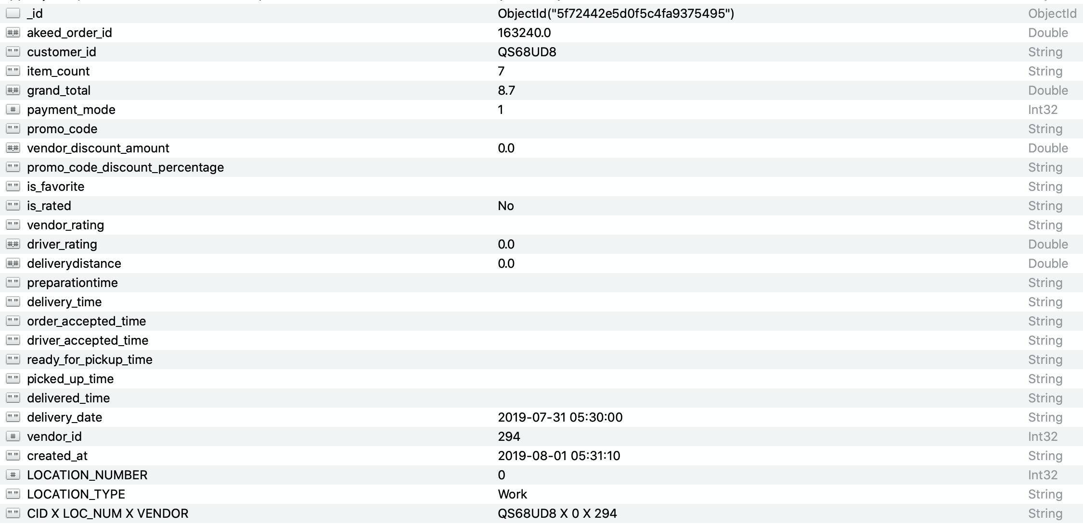

* **TEST_CUSTOMERS**

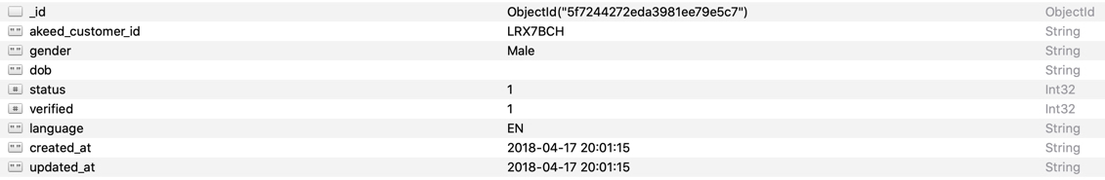

* **TEST_FULL**

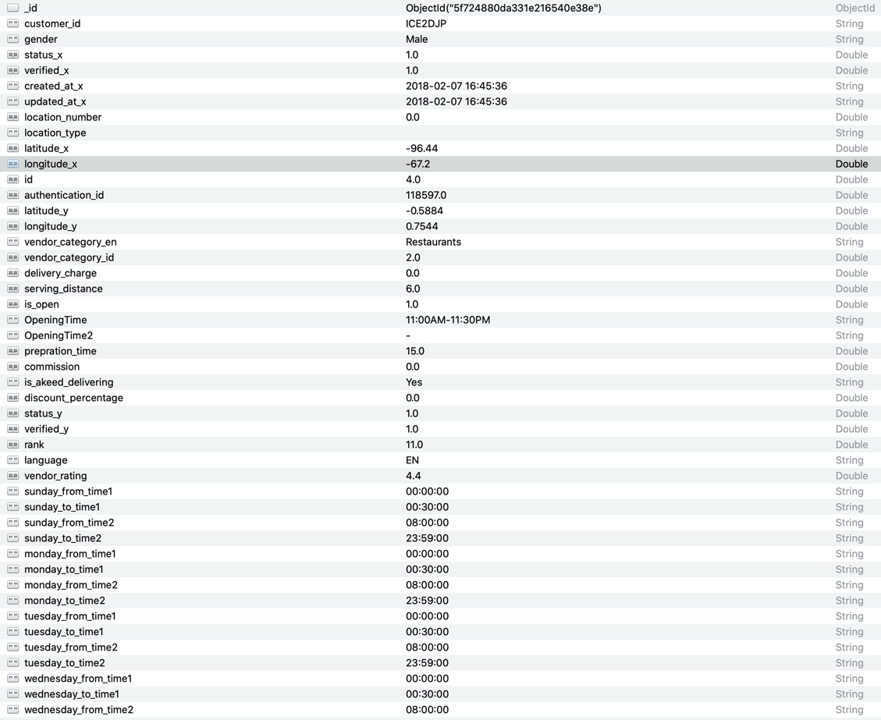

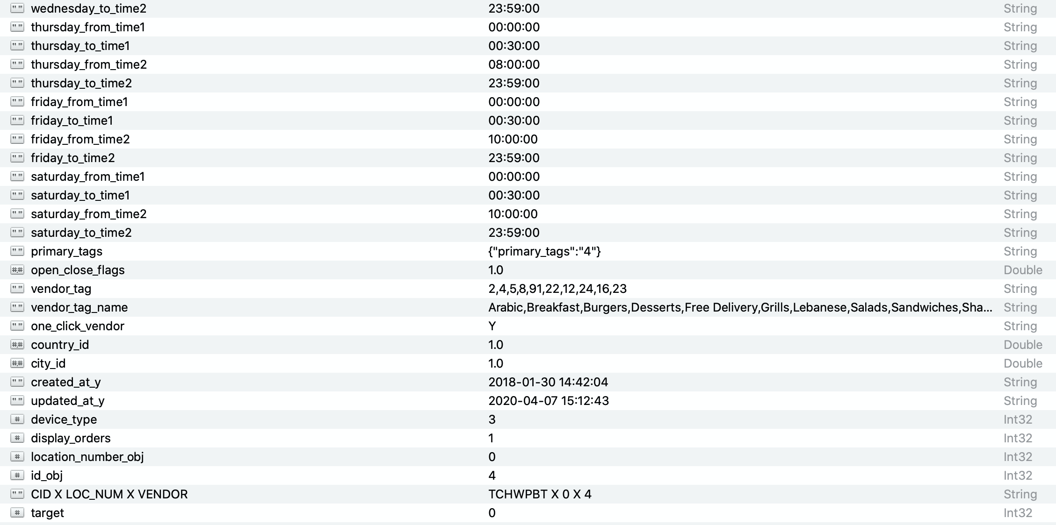

* **TEST_LOCATIONS**

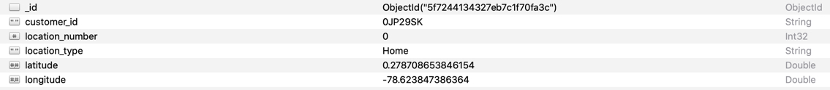

* **TRAIN_CUSTOMERS**

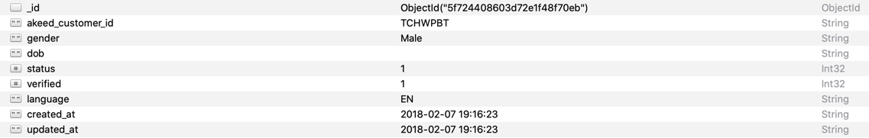

* **TRAIN_FULL**

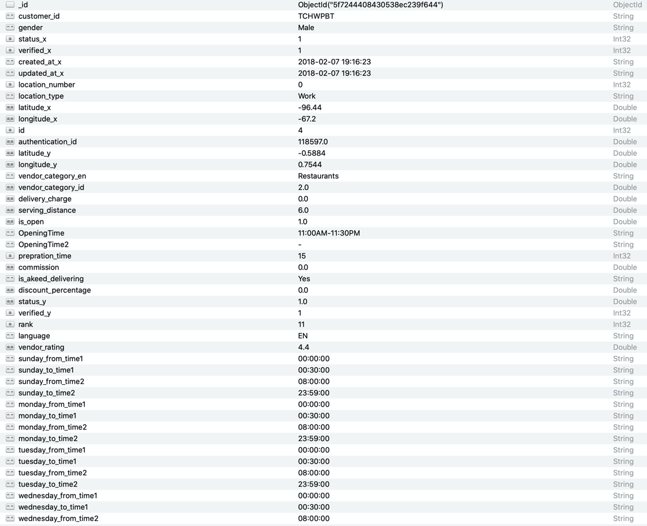



* **TRAIN_LOCATIONS**

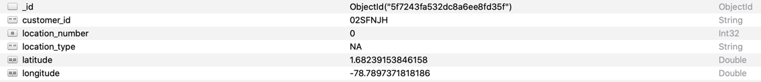

* **VENDORS**

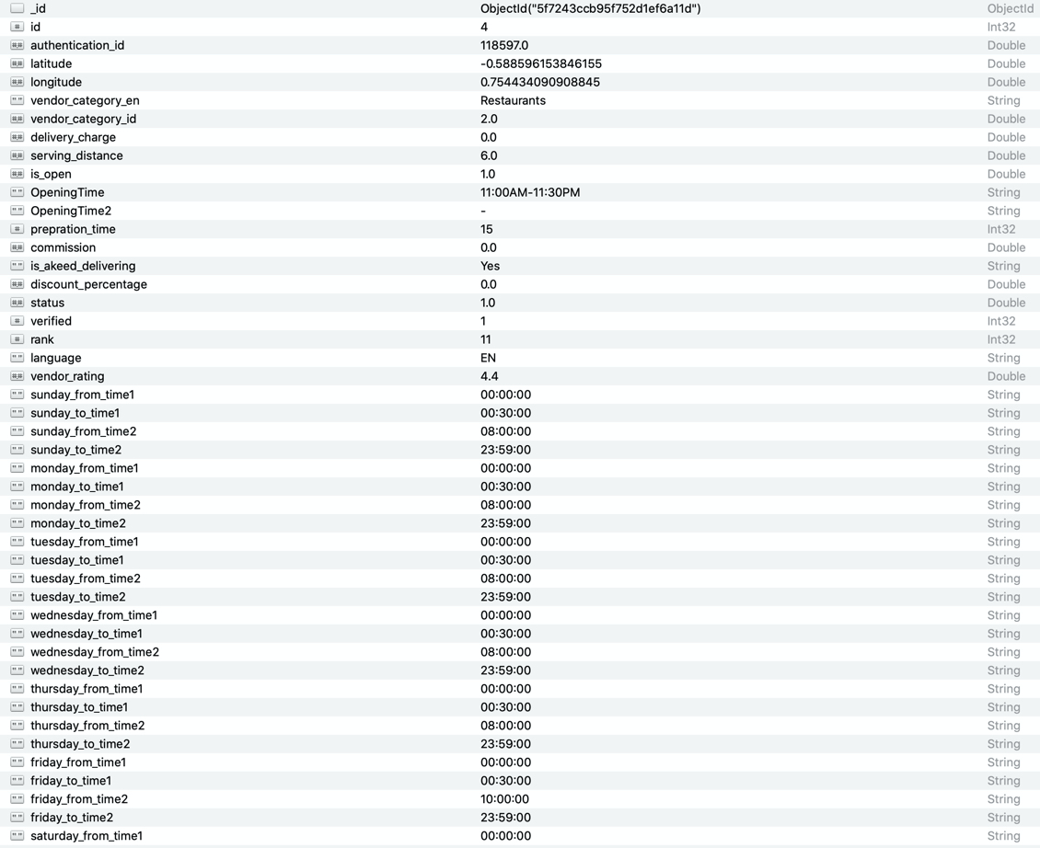

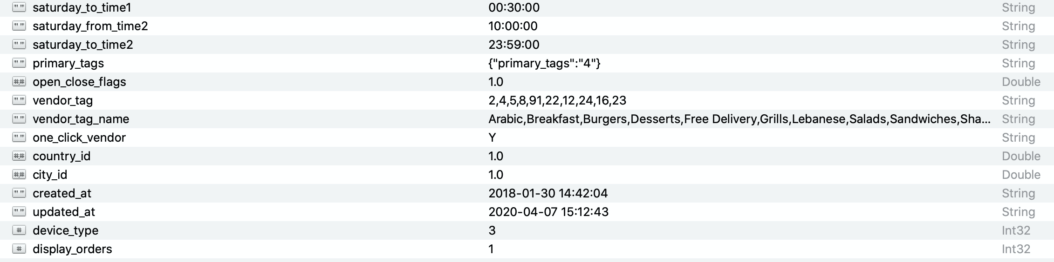

## **PostgreSQL**

* **ORDERS**

* **TEST_CUSTOMERS**

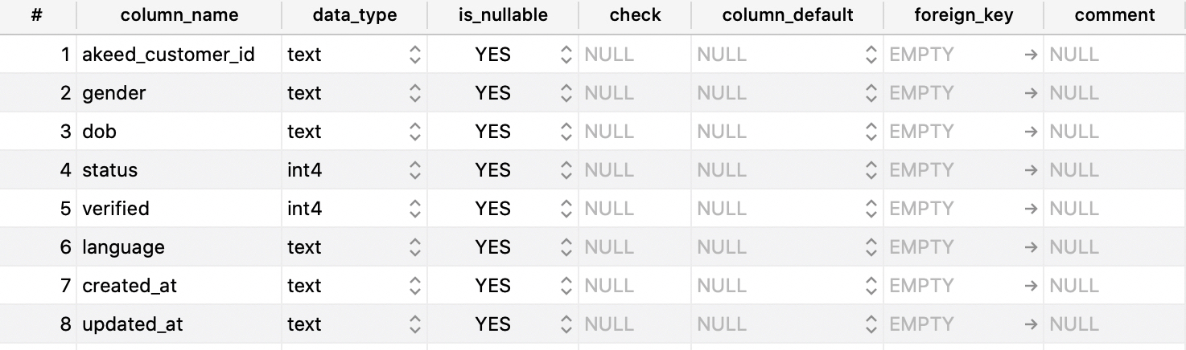

* **TEST_FULL**

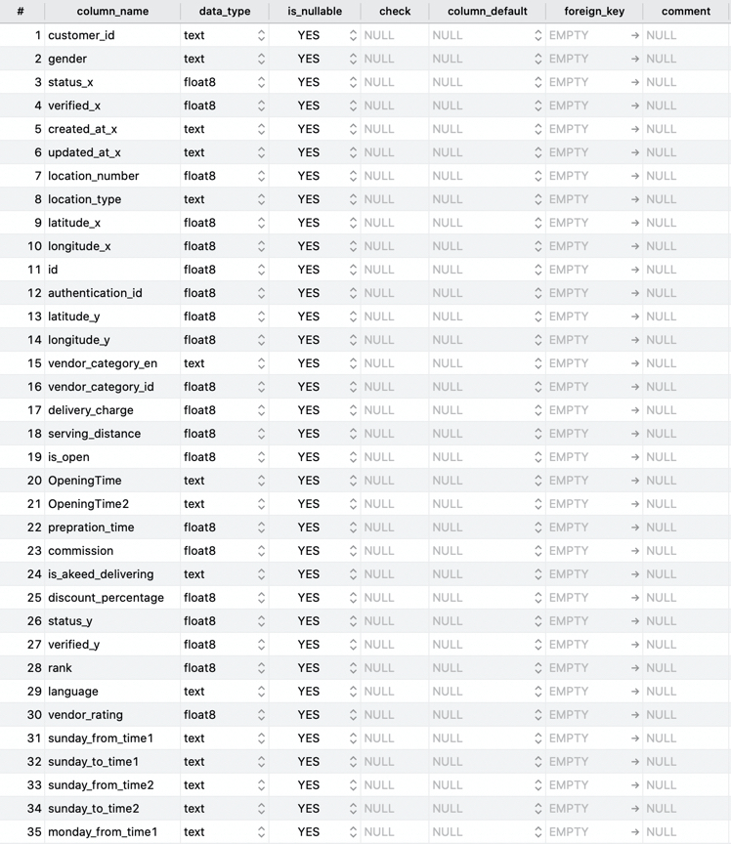

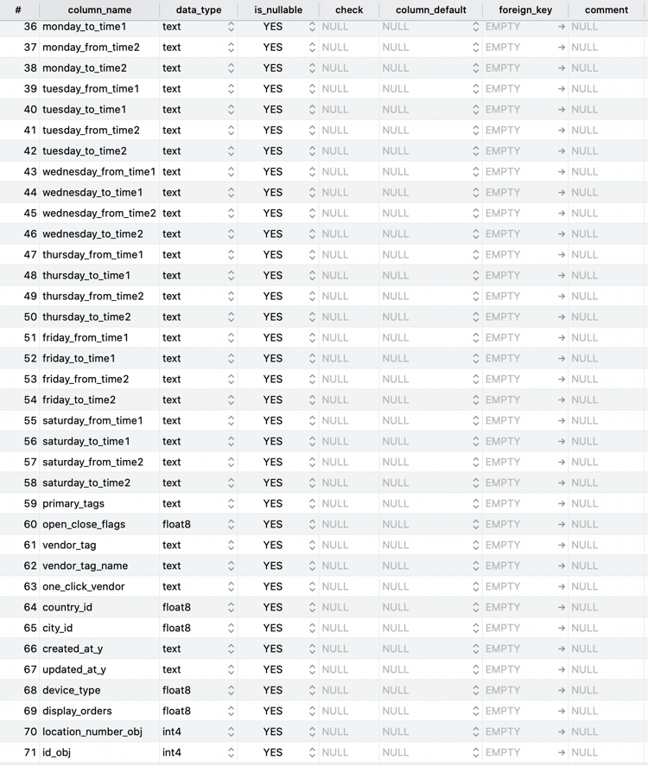

* **TEST_LOCATIONS**

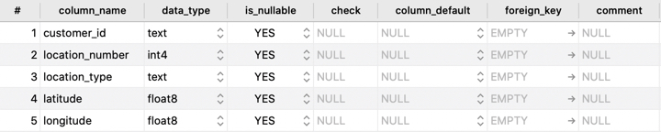

* **TRAIN_CUSTOMERS**

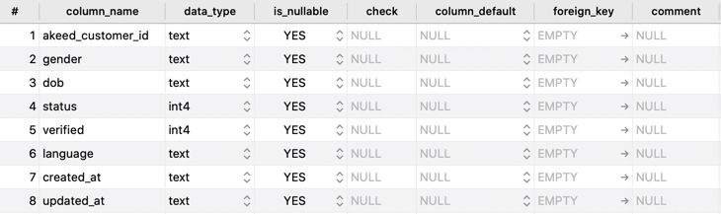

* **TRAIN_FULL**

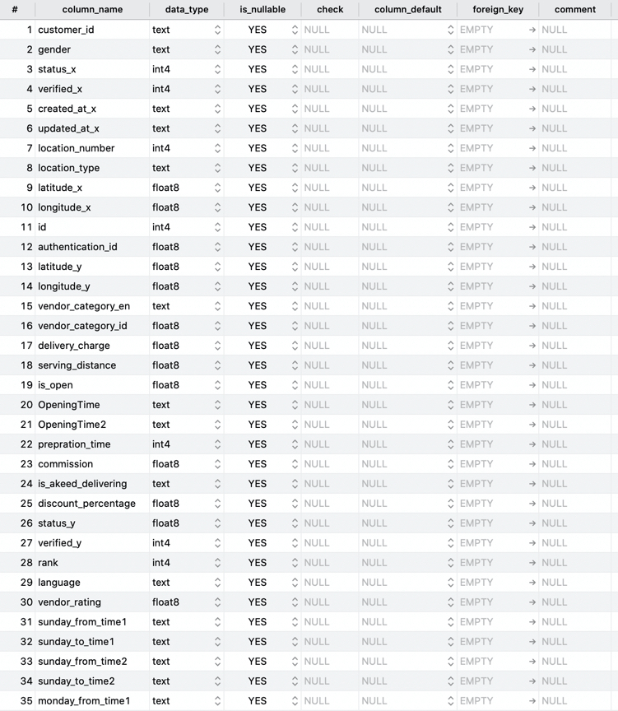

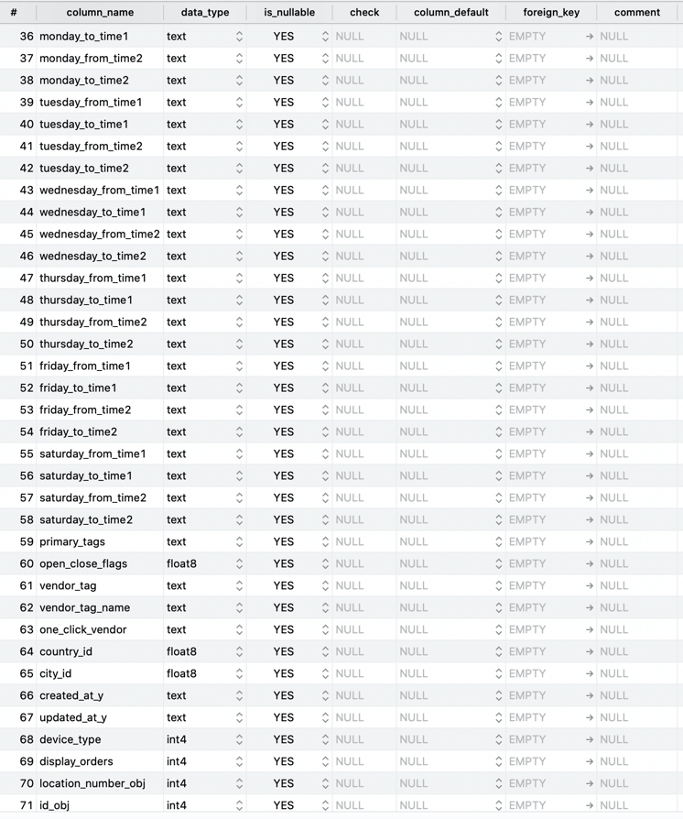

* **TRAIN_LOCATIONS**

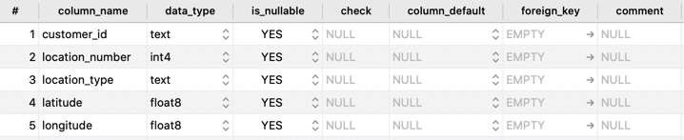

* **VENDORS**

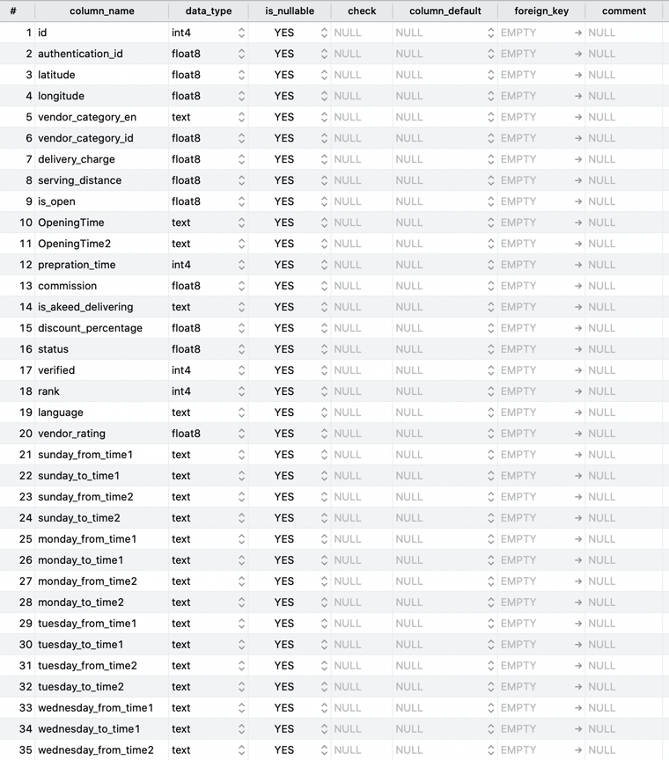

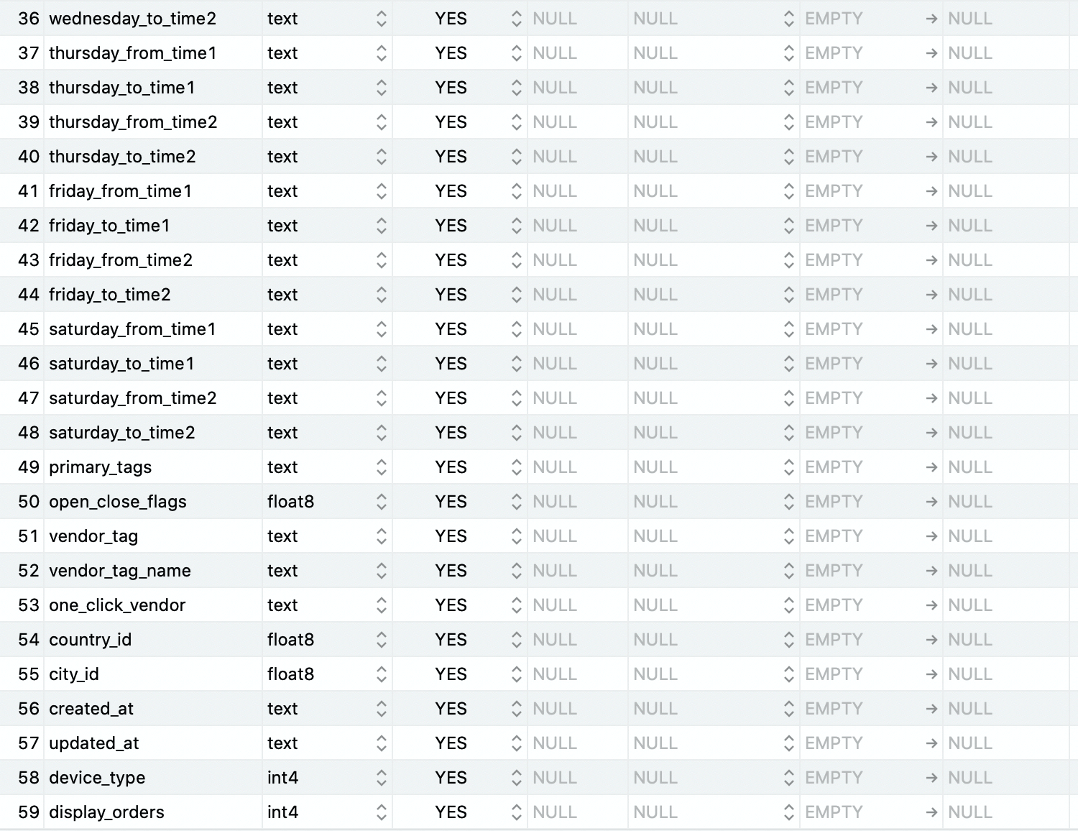

## **Cassandra**

* **ORDERS**

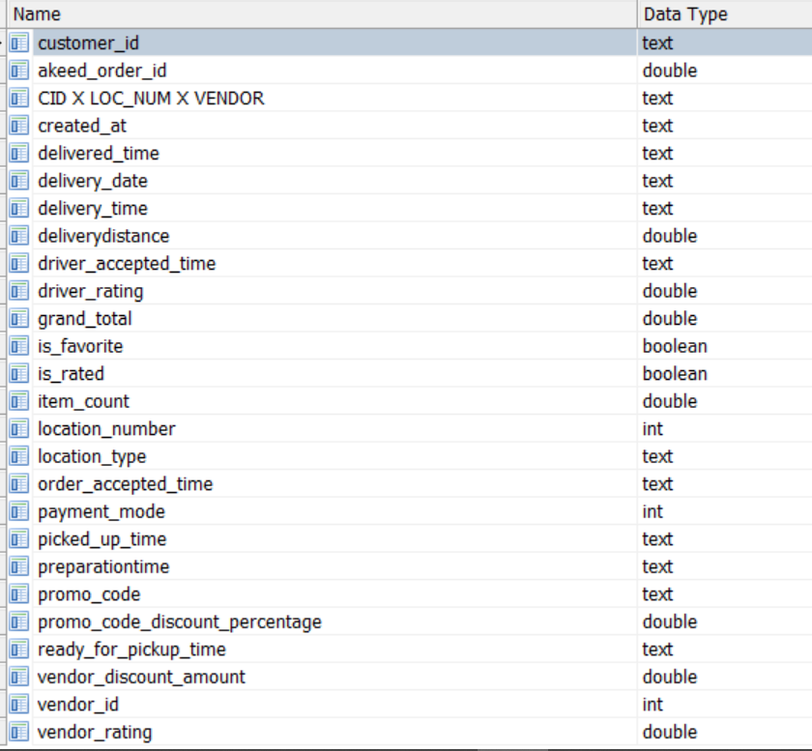

**135303 rows imported from 1 files in 6.011 seconds (0 skipped).**

* **TEST_CUSTOMERS**

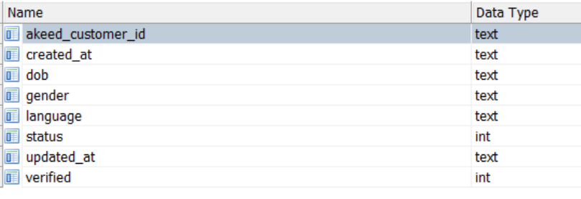

* **TEST_FULL**

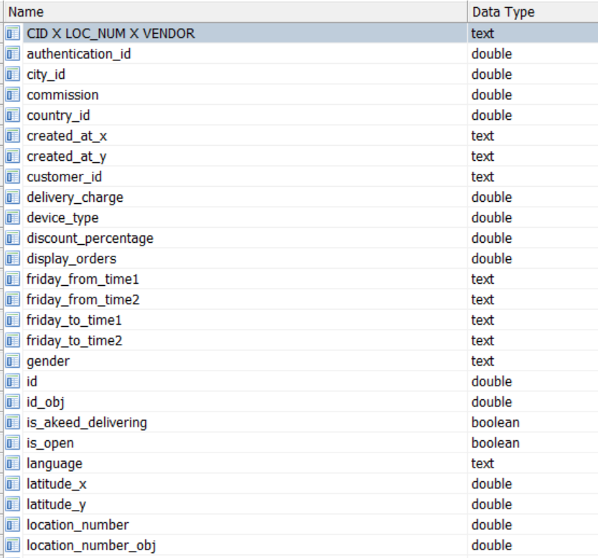

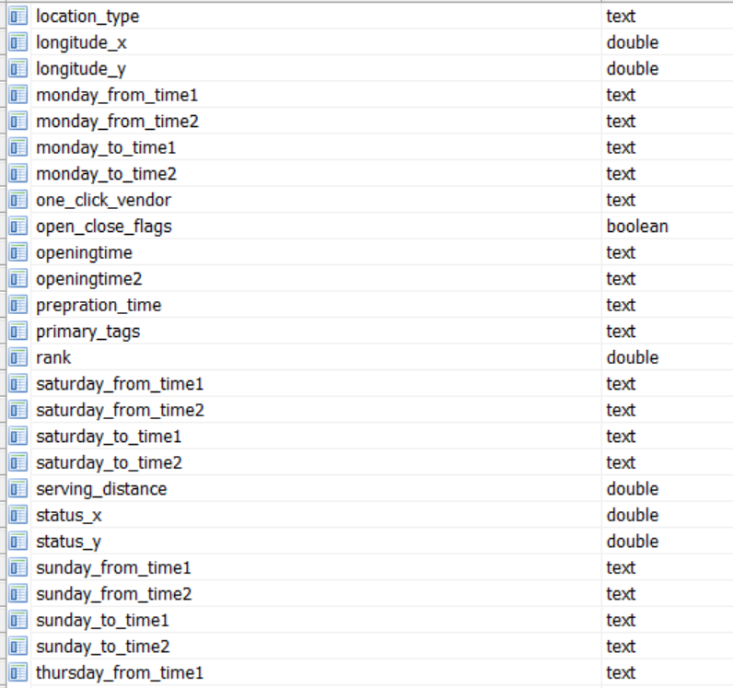

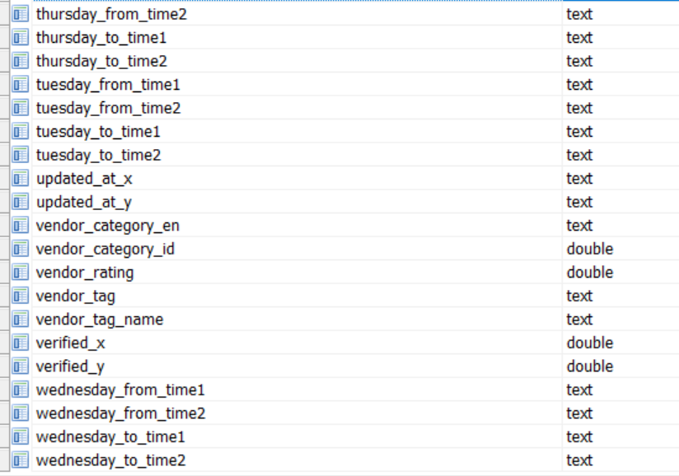

**Processed: 1672000 rows; Rate: 5744 rows/s; Avg. rate: 9557 rows/s**

**1672000 rows imported from 1 files in 2 minutes and 54.947 seconds (0 skipped).**

* **TEST_LOCATIONS**

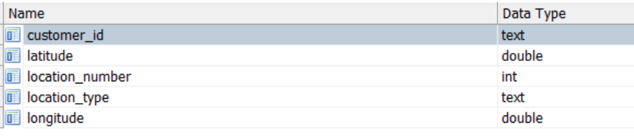

* **TRAIN_CUSTOMERS**

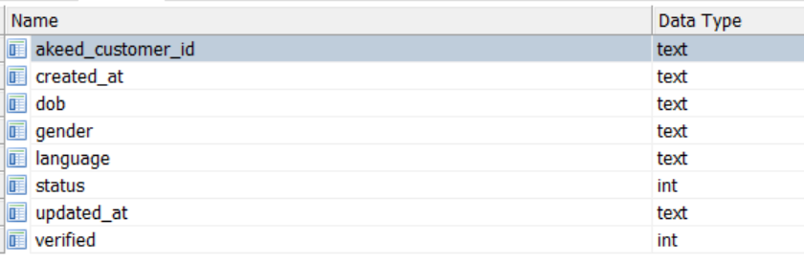

* **TRAIN_FULL**

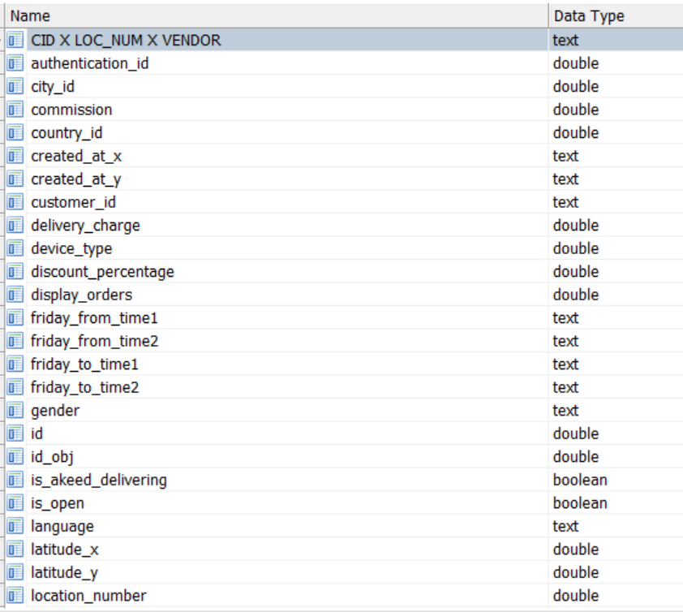

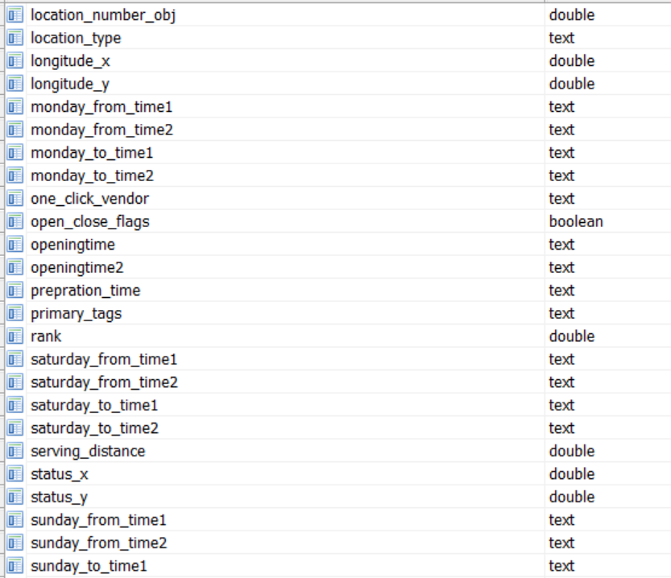

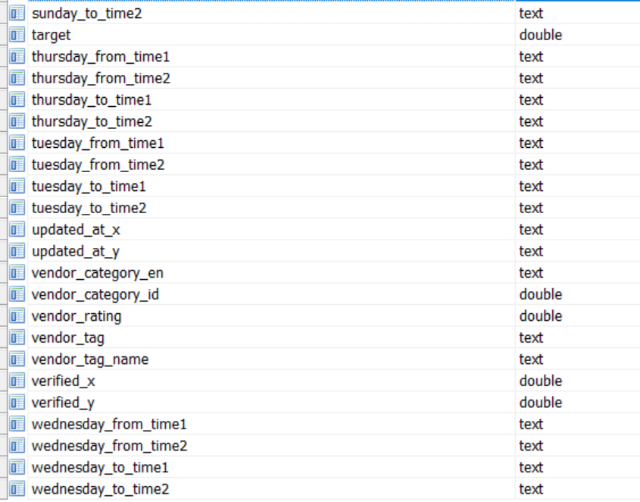

**Processed: 5802400 rows; Rate: 6884 rows/s; Avg. rate: 10068 rows/s**

**5802400 rows imported from 1 files in 9 minutes and 36.297 seconds (0 skipped).**

* **TRAIN_LOCATIONS**

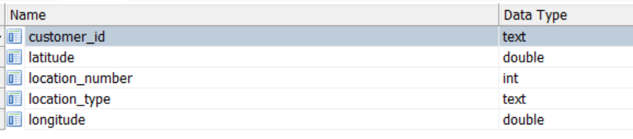

* **VENDORS**

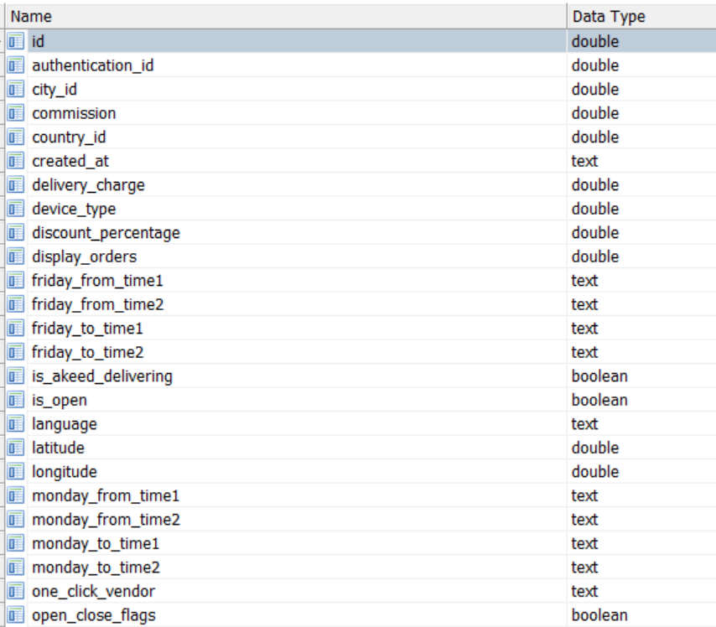

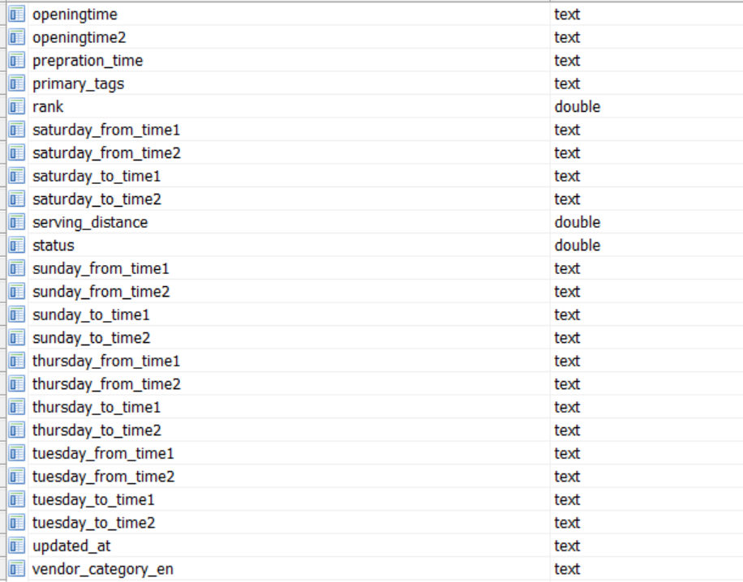

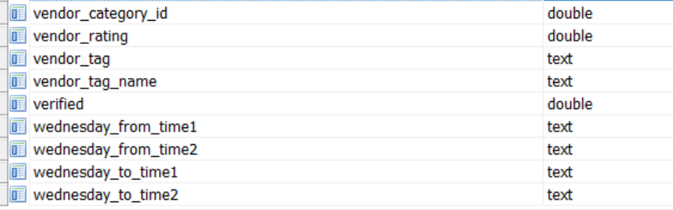

# **Queries used for each of the below operation**

## **MongoDB**

### WRITE

Record Exist

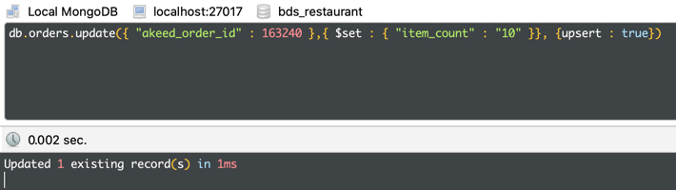

Record Not Exist

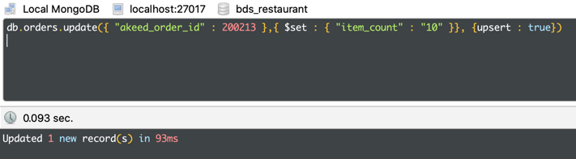

### READ

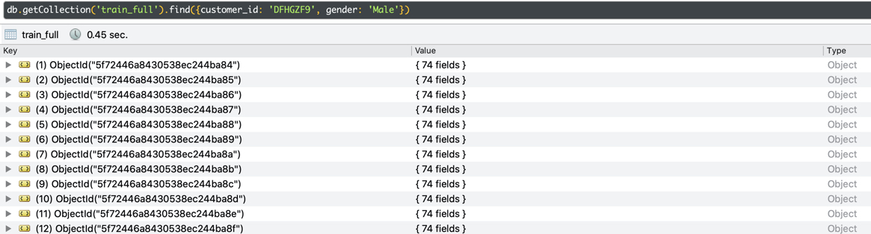

### DELETE

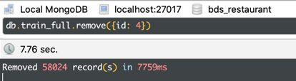

### GROUP BY & ORDER BY

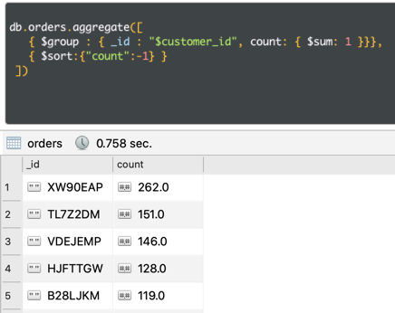

## **PostgreSQL**

### WRITE

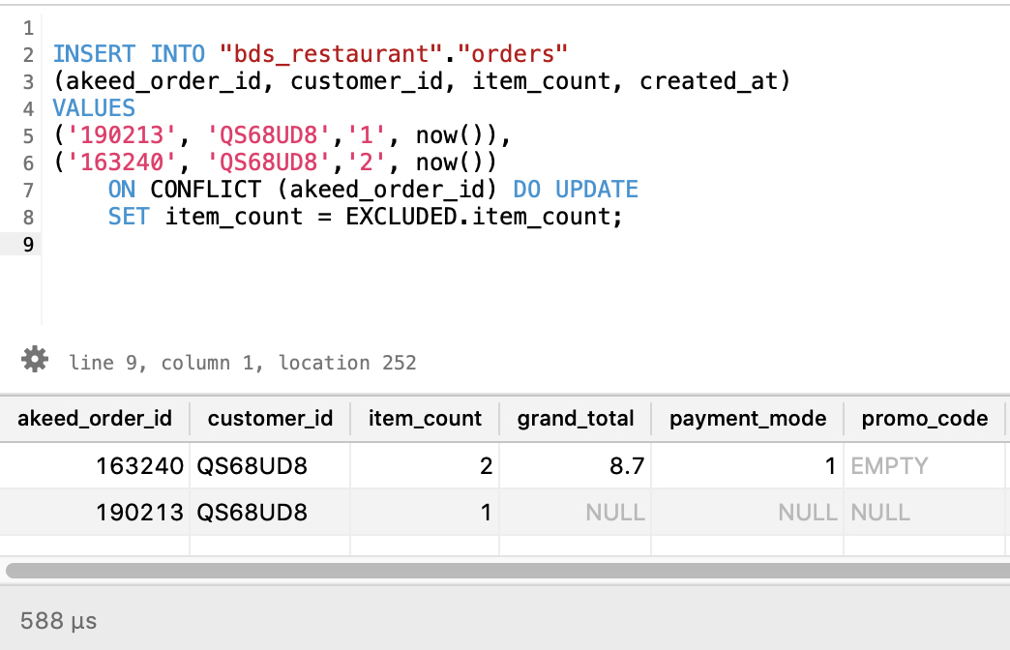

### READ

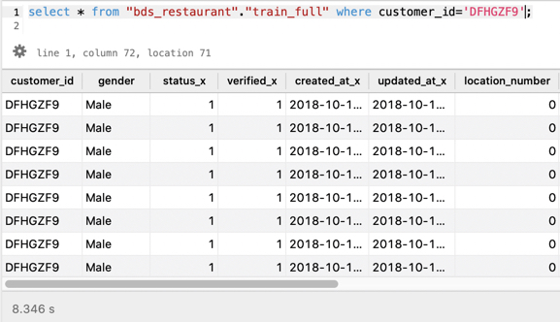

### DELETE

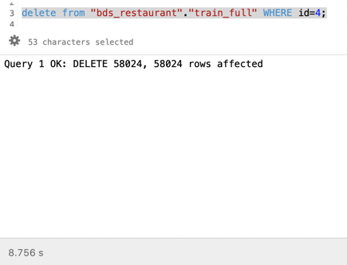

### GROUP BY & ORDER BY

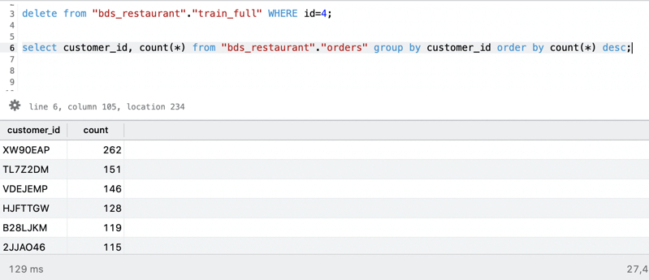

## **Cassandra**

### WRITE

* Existing record got updated

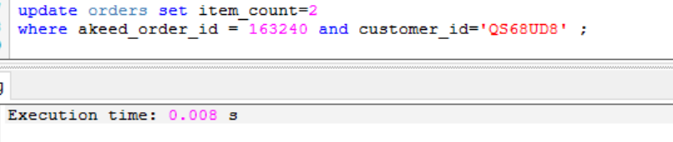

* New record got created, which was not there.

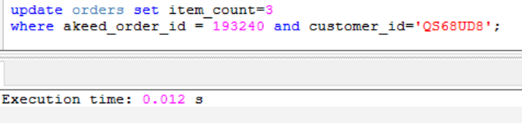

### READ

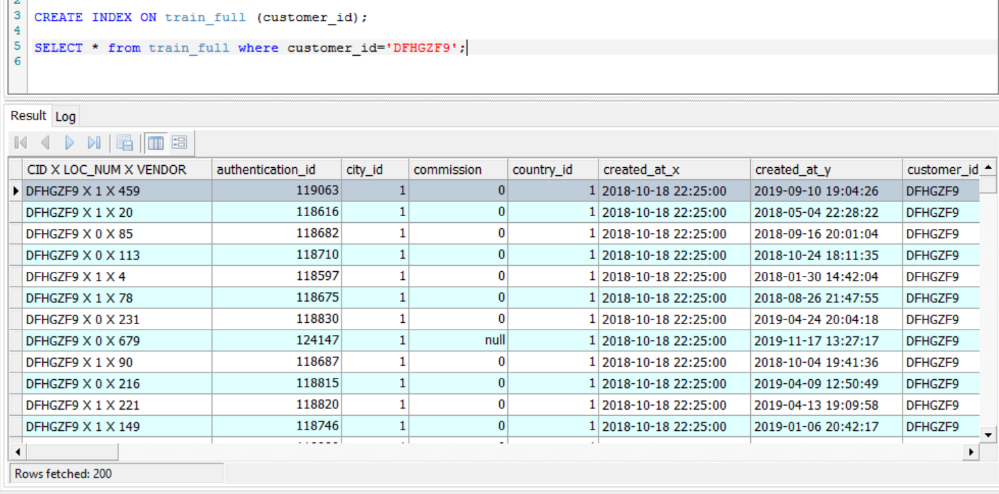

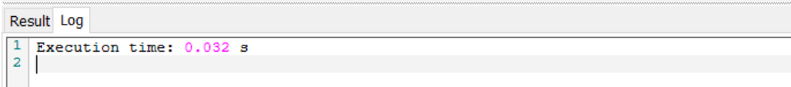

### DELETE

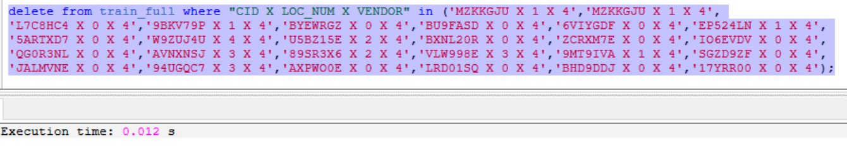

* Delete in Cassandra is only possible with including all keys in where condition.

### GROUP BY & ORDER BY

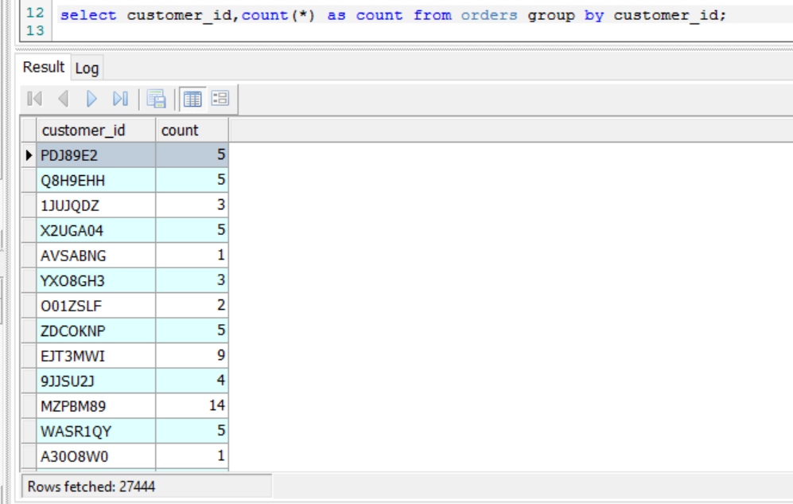



ORDER BY :

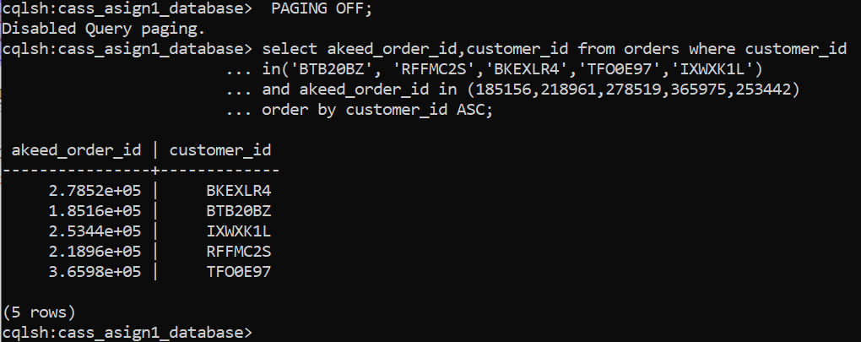

# **Performance parameters considered**

MongoDB is the leading document database. It is built on a distributed, scale-out architecture and has become a comprehensive cloud-based platform for managing and delivering data to applications. MongoDB handles **transactional**, **operational**, and **analytical workloads** at scale. If your concerns are time to market, developer productivity, supporting DevOps and agile methodologies, and building stuff that scales without operational gymnastics, MongoDB is the way to go.

PostgreSQL is a rock solid, open source, enterprise-grade SQL database that has been expanding its capabilities for 30 years. Everything you would ever want from a relational database is present in PostgreSQL, which relies on a scale-up architecture. If your concerns are compatibility, serving up thousands of queries from hundreds of tables, taking advantage of existing SQL skills, and pushing SQL to the limit, PostgreSQL will do an awesome job.

Several key performance factors influence database performance. Understanding these factors helps identify performance opportunities:

* **Query Performance**As we compared with all the DB, MongoDB performance is better. Cassandra DB performance is much better compared with PostgreSQL. Cassandra DB does not provide the ability to run the query with Non-key.
* **Performance of Import CSV file into DB**MongoDB provides the database tool called “mongoimport” which took ~5mins of to load ~4GB of data into DB but PostgreSQL took around ~1hour time. Cassandra import functionality better compared with PostgreSQL.
* **Tweaking of DB Schema**If we are at the beginning of a development project and are seeking to figure out your needs and data model by using an agile development process, MongoDB will shine because developers can reshape the data on their own, when they need to. MongoDB enables you to manage data of any structure, not just tabular structures defined in advance. In a typical relation database this involves lot of effort to make it happen.
* Even Though we have not evaluated below metrics as part of this Assignment but found the parameters which helps to finalize the database on this
* Scalability
* Resilience
* Security
* System Resources

# **Visualizations based on the performance parameters**

* + **Without Indexing**

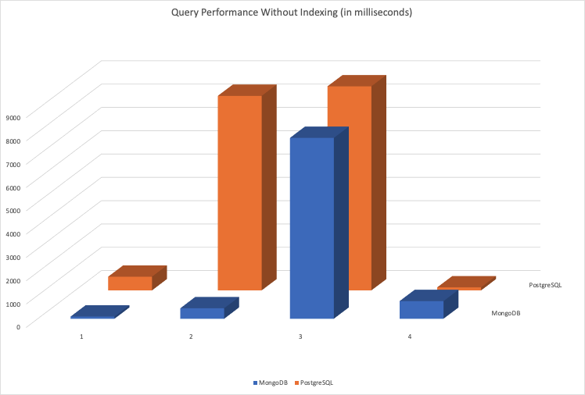

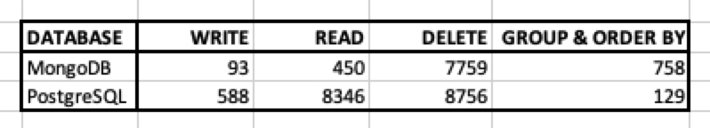

* + **With Indexing**

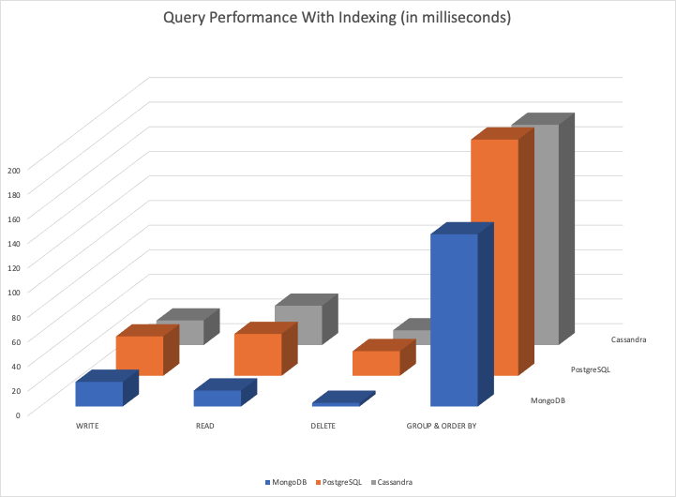

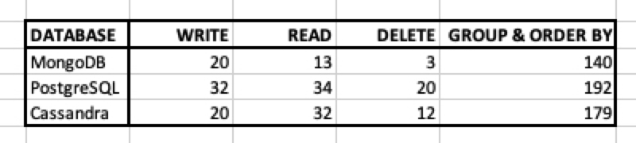

**NOTE**: Cassandra does not provide ability to execute query without index. Hence not included the cassandra comparison in the above chart

# **Tabular , quick summary of the prototyping exercise**

**MongoDB vs PostgreSQL vs Cassandra Terminology and Concepts**

|  |  |  |
| --- | --- | --- |
| **MongoDB** | **PostgreSQL** | **Cassandra** |
| Collection | Table | Table |
| Document | Row | Row |
| Field | Column | Column |
| Embedded documents, $lookup & $graphLookup, $unionWith | JOINs, UNIONs | It's not supported, but it can be achieved by using SparkSQL with Cassandra |
| Aggregation Pipeline | GROUP_BY | GROUP_BY |
| Sort | ORDER_BY | ORDER_BY |

# **Clearly spelt out recommendation**

### **MongoDB** is the best choice for this usecase

* + If we are supporting an application will have to scale in terms of volume of traffic or size of data (or both) and that needs to be distributed across regions for data locality or data sovereignty, MongoDB’s scale-out architecture will meet those needs automatically.
  + If you want a multi-cloud database that works the same way in every public cloud, can store customer data in specific geographic regions, and support the latest serverless and mobile development paradigms, MongoDB Atlas is the right choice.
  + With the current emphasis on “Big Data”, NoSQL databases have surged in popularity. These databases are claimed to perform better than SQL databases.
  + MongoDB’s document data model maps naturally to objects in application code, making it simple for developers to learn and use. Documents give you the ability to represent hierarchical relationships to store arrays and other more complex structures easily. JSON documents can store data in fields, as arrays, or even as nested sub-documents. In this way, related information can be stored together for fast query access through the rich and expressive MongoDB query language.
  + This paper compares key-value store implementations on NoSQL and SQL databases. While NoSQL databases are generally optimized for key-value stores, SQL databases are not. Yet, we ﬁnd that not all NoSQL databases perform better than the SQL database.
  + MongoDB stores data as documents in a binary representation called BSON (Binary JSON). Fields can vary from document to document; there is no need to declare the structure of documents to the system – documents are self-describing. If a new field needs to be added to a document, then the field can be created without affecting all other documents in the collection, without updating a central system catalog, updating an ORM, and without taking the system offline. Optionally, schema validation can be used to enforce data governance controls over each collection.
  + MongoDB allows you to store data in almost any structure, and each field – even those deeply nested in subdocuments and arrays – can be indexed and efficiently searched.
  + MongoDB adds elements to the document model and the query engine to handle both geospatial and time series tagging of data. This expands the type of queries and analytics that can be performed on a database.
  + BSON includes data types not present in JSON data (e.g., datetime, int, long, date, floating point, and decimal128, and byte array) offering type-strict handling for multiple numeric types instead of a universal "number" type. Schema validation enables you to apply governance and data quality controls to your schema.
  + Query performance in MongoDB can be accelerated by creating indexes on fields in documents and subdocuments. MongoDB allows any field of a document, including those deeply nested in arrays and subdocuments, to be indexed and efficiently queried.
  + We observe that even with in NoSQL databases there is a wide variation in performance based on the type of operation (such as read and write). We also observe little correlation between performance and the data model each database uses.
  + Casandra is slow on read operations, but is reasonably good for write and delete operations. MongoDB are the fastest two overall for read, write and delete operations.
  + Like any application software, NoSQL implementations gothrough changes and thus performance improvements and degradations are likely to happen through these changes.
  + Consequently, one will need to compare databases not only at the application design stage but also at regular intervals to enable switching to the most suitable database implementation.
  + Tiered software development processes would help isolate the database backend to facilitate such switching when deemed necessary

# **Any other observation / finding that you feel is important for this exercise**

* + While importing CSV files into all the databases observed that, the MongoDB performance is high compared to PostgreSQL & Cassandra.
  + MongoDB provides the database tool “mongoimport” to import CSV files into DB. For PostgreSQL used the database GUI tool “TablePlus” to import all the CSV files to DB.
  + When performing “WRITE” operation for ORDERS table, the PostgreSQL was not allowing and throwing the unique ID not exist hence we needed to create the Unique index for the ORDERS table then PostgreSQL allowed us to perform the operation. But in MongoDB the unique ID issue not happened and able to perform the operation successfully.
  + There are many limitations in cassandra DB in crud operations.
    1. Select: It only allows key column or index column for where condition in select query. Any non key or non indexed column can’t be used in where condition.
    2. Delete: Only key columns can be used to delete records in where condition.
    3. Group by : Group by option only accept as arguments primary key column names in the primary key order.
    4. Order by: ORDER BY clauses can select a single column only. That column has to be the second column in a compound PRIMARY KEY.

ORDER BY is only supported when the partition key is restricted by an EQ or an IN.

* + 1. Table creation: Table can’t be created without a Primary key. Need to plan all operations to be done in the table so that respective key combination and cluster ordering can be defined, because it has limitations in all operations.
    2. Nested queries are not allowed in Cassandra CQL
  + Cassandra DB import was quick and its query retrieval is fast because it works mostly on key attributes but due to so many limitations, it’s less user friendly in data extraction and analysis.